**Name: Tejal Shetty**

**Subject: My SQL Essentials**

**Project: Ecommerce**

**Topic: Online_Store**

**Introduction:**

My Project is regarding online store. As Nowadays, online shopping is trending so to have a seamless shopping experience for customers, I have created 5 tables such as Employees, Customers, Orders,

Products and Sales. The order table has a foreign key that connect to Employees and Customer table respectively also Sales table has a foreign key connected to Products table. The relationship between the tables helps to maintain data integrity and enables to access data and retrieve information.

Following are the steps that how I have created database in which I have tables also with the help of query, constraints, functions and etc. I have got the output: -

1. I have created a database :- Online_Store
2. Five tables are Employees, Customers, Orders, Products & Sales.

Following are the columns respectively:-

* Employees- Employee_Id, Name, Email, department, hire_date.
* Customers-Customer_id ,Name, Email, address, Contact_number.
* Orders- order_id, customer_id, Employee_id, order_date, Status.
* Products-Product-id,name,description,price.
* Sales- Sales_id,Product_id,Quantity,sales_date.

Create database Online_Store;

Use Online_Store;

Create table Employees (

Employee_id int auto_increment primary key,

EmpName varchar(50),

Email varchar(50),

Department varchar(50),

hire_date date );

Create table Customers (

customer_id int primary key,

name varchar(50) not null,

email varchar(50) not null unique,

address varchar(50),

contact_number varchar(11)not null

);

Create table Orders (

order_id int auto_increment primary key,

customer_id int,

Employee_id int,

order_date date,

status varchar(50),

foreign key (Employee_id) references Employees(Employee_id),

foreign key (Customer_id) references Customers(customer_id)

);

Create table Products (

Product_id int auto_increment primary key,

Name_id int,

name varchar(50),

description varchar(50),

Price decimal(10,2)

);

Create table Sales (

Sale_id int primary key,

Product_id int,

Quantity int,

sale_date date,

foreign key (Product_id) references Products(Product_id)

);

**describe Employees;**

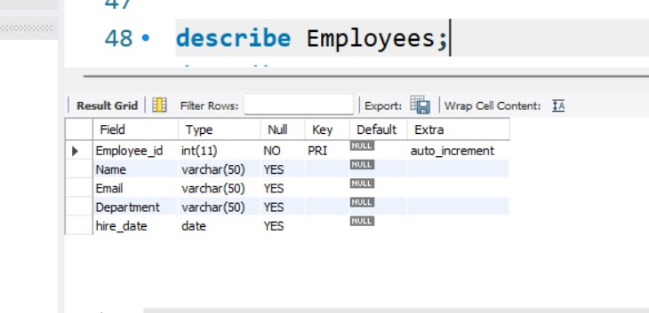

**describe customers;**

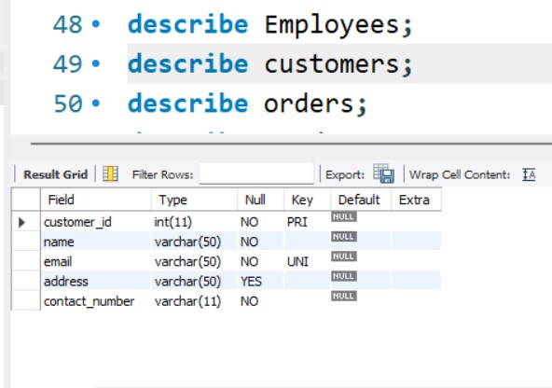

**describe orders;**

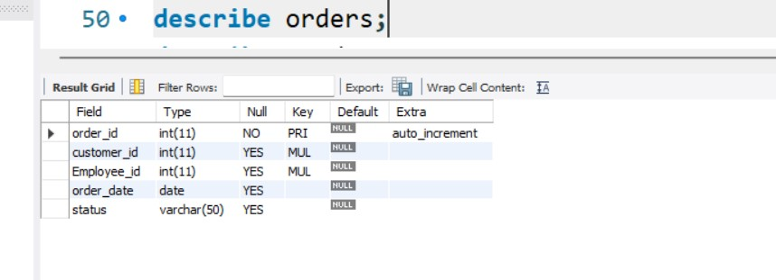

**describe products;**

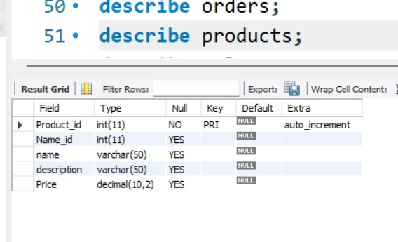

**describe Sales;**

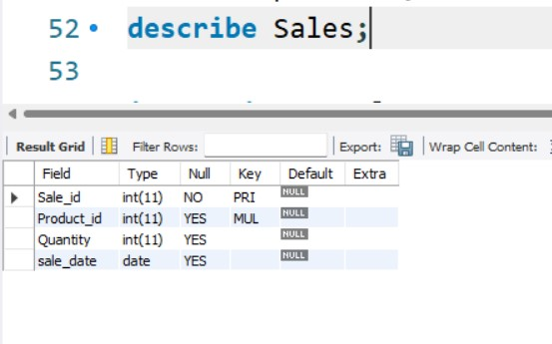

**insert into Employees**

**(EmpName,Email,department,hire_date)**

**values**

**("Tejal","t@gmail.com","Finance","2023-02-02"),**

**("Sheetal","s@gmail,com","Marketing","2022-07-03"),**

**("Rahul","r@gmail.com","Accounting","2021-06-01"),**

**("Mihir","m@gmail.com","Sales","2020-05-02");**

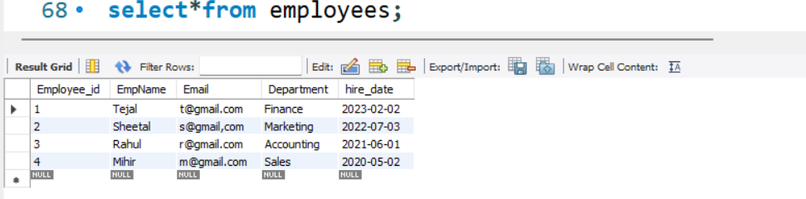

**insert into customers**

**(Customer_id,name,email,address,contact_number)**

**values**

**(101,"Raj","r@gmail.com","Borivali","9082274549"),**

**(102,"Shiv","s@gmail.com","Thane","9702511781"),**

**(103,"Mohan","m@gmail.com","Andheri","8108339639"),**

**(104,"Kriti","k@gmail.com","Malad","9967765529"),**

**(105,"Anita","a@gamil.com","Andheri","8425996488");**

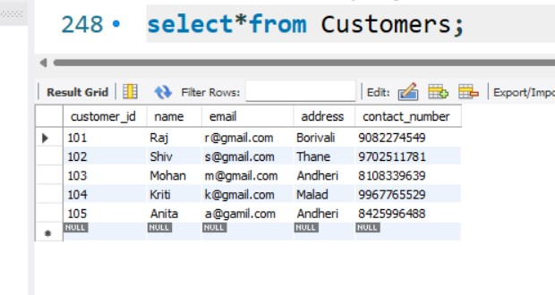

**insert into orders**

**(customer_id,employee_id,order_date,status)**

**values**

**(101,1,"2024-05-23","Pending"),**

**(102,2,"2024-05-15","Processing"),**

**(105,3,"2024-05-01","Cancelled"),**

**(104,4,"2024-05-14","Delivered"),**

**(103,3,"2024-05-13","Shipped");**

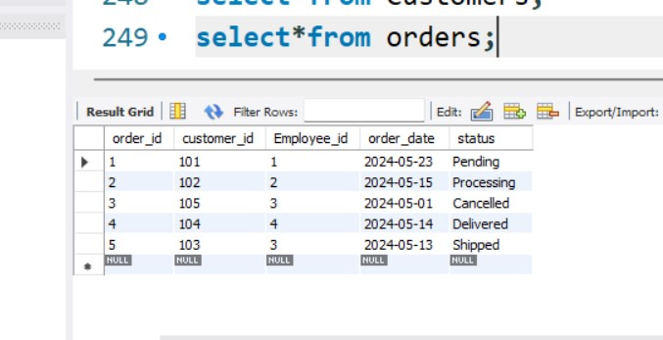

**insert into Products**

**(name_id,name,description,Price)**

**values**

**(1,"Laptop","Full HD Display",999.99),**

**(2,"Smartphone","64GB storage",599.99),**

**(3,"Headphone","noise cancellation",249.05),**

**(4,"Tablet","128GB storage",400.00),**

**(5,"Computer",null,500.05);**

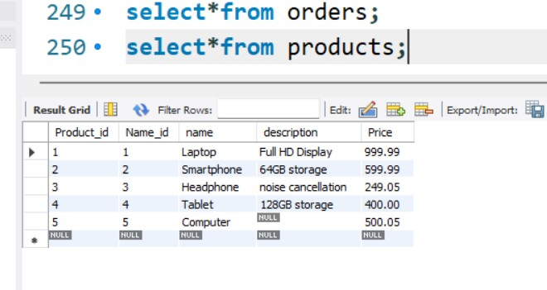

**insert into Sales**

**(Sale_id,Product_Id,Quantity,Sale_date)**

**values**

**(1,2,1,"2024-06-03"),**

**(2,1,2,"2024-05-15"),**

**(3,3,1,"2024-06-07"),**

**(4,4,4,"2024-06-01");**

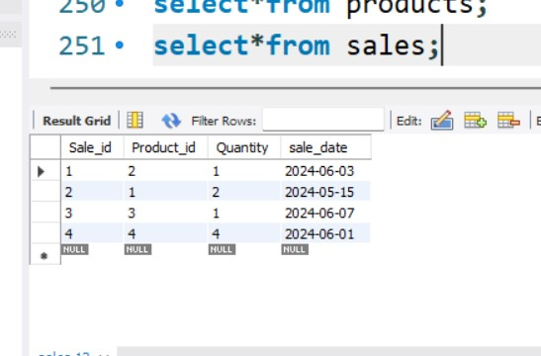

**-- to rename column:-**

**ALTER TABLE Employees**

**change column EmpName Emp_Name varchar(20);**

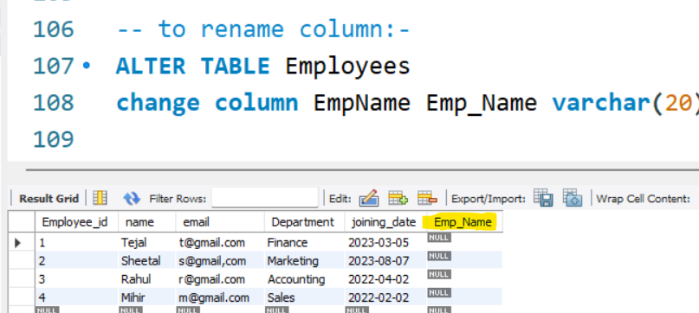

**-- to limit clause:-**

**Select*from Employees limit 3;**

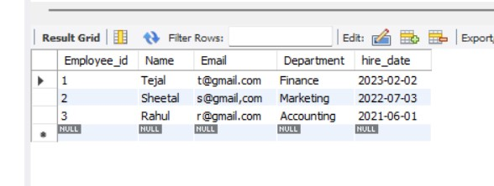

**-- where clause:-**

**Select*from Employees where name = "Tejal";**

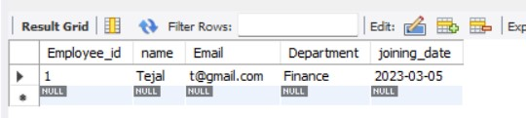

**-- Comparison operaters on numerical data:-**

**Select*from Employees where department ="Marketing";**

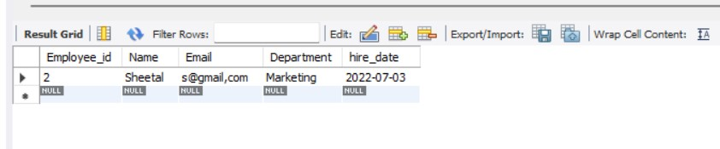

**Select*from Employees where Employee_Id!=3;**

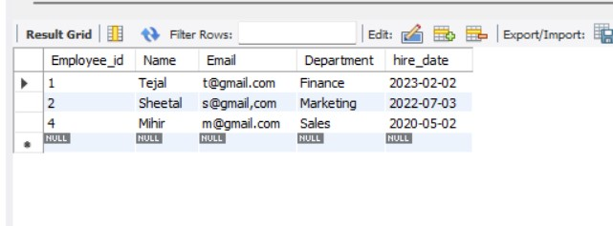

**select*from products;**

**Select*from Products where Price< 599.99;**

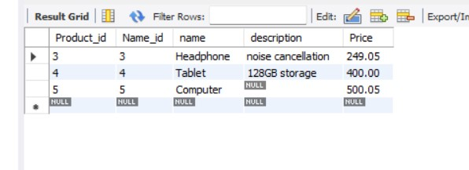

**Select*from Products where Price>=400.00;**

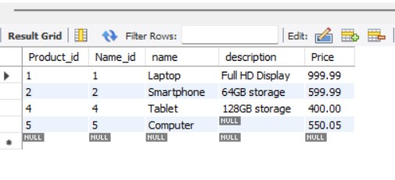

**-- Arithmatics:-**

**Select Product_id + Price as sum from products;**

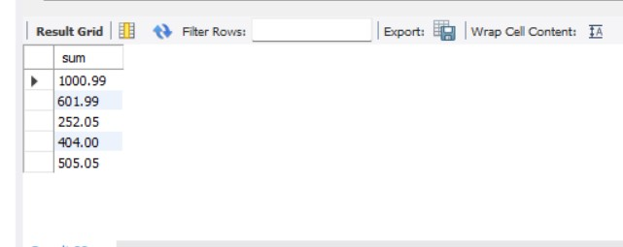

**-- to test null values and is not null values:-**

**Select Product_id , Name , Price from Products**

**where Description is null;**

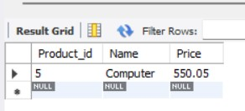

**-- update existing records in table**

**SET SQL_SAFE_UPDATES = 0;**

**update products**

**set Price = 550.05**

**where name ="Computer";**

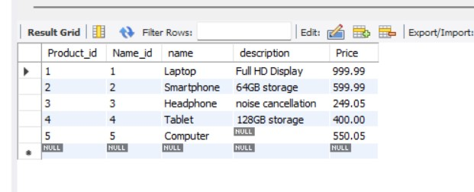

**select*from products;**

**select*from sales;**

**-- to delete existing record in a table:-**

**delete from sales where sale_id=1;**

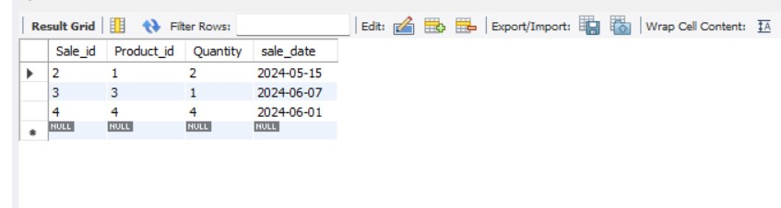

**-- insert row or add row in a table:-**

**insert into Sales**

**(Sale_id,Product_Id,Quantity,Sale_date)**

**values**

**(1,2,1,"2024-06-03");**

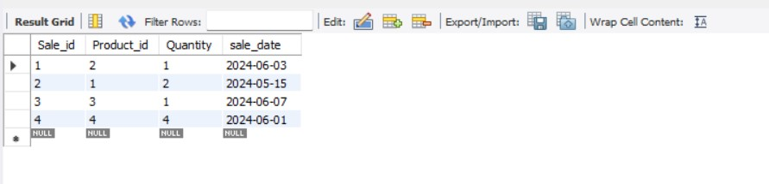

**-- Aliases:-**

**Select name as Product_name from products;**

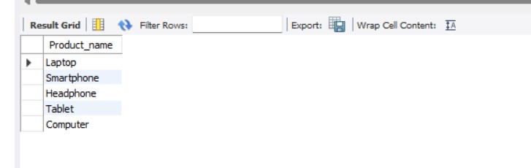

**-- Logical operators:-**

**Select * from products**

**where name like "S%";**

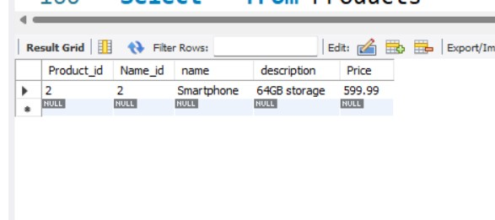

**Select * from Products**

**where Price between 599.99 and 1000;**

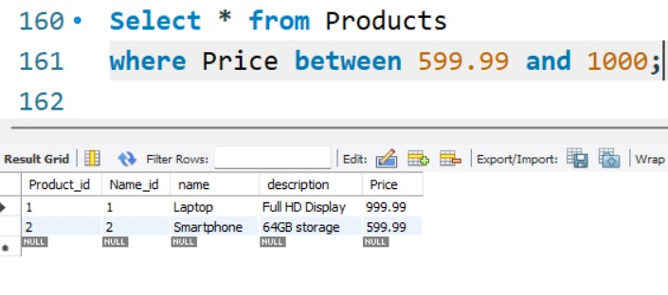

**Select*from Employees;**

**Select * from Employees**

**where Name="Tejal" and department="Finance";**

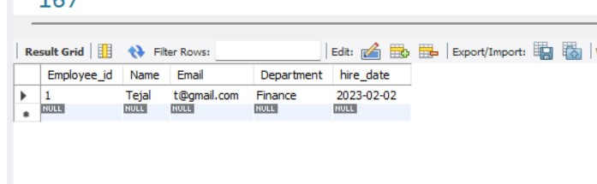

**Select * from Employees**

**where Name="Tejal" or department="Marketing";**

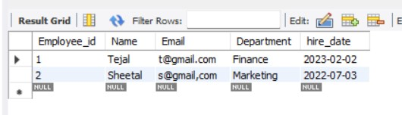

**Select * from Employees**

**where (Name="Sheetal" and Department="Finance") or name="Rahul";**

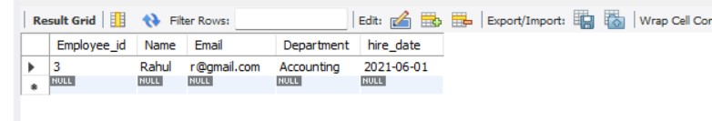

**Select * from Employees**

**where name in("Rahul","Tejal");**

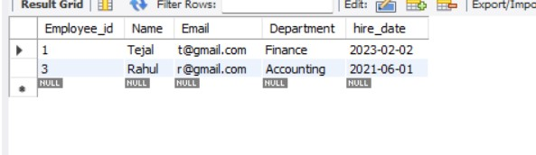

**-- order by**

**select*from orders;**

**Select * from orders**

**order by order_id desc;**

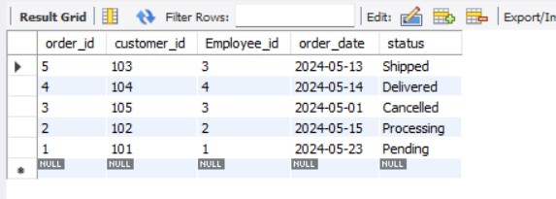

**-- Aggregate functions:-**

**select*from customers;**

**select count(name) as customer_name from customers;**

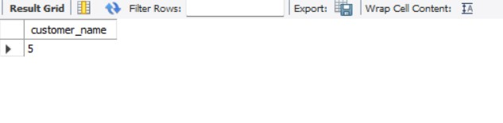

**select*from Sales;**

**select sum(Quantity) as total_sales_Quantity from sales;**

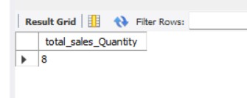

**select min(Quantity) as minimum from sales;**

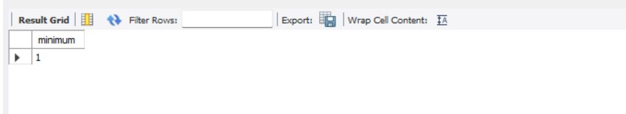

**-- to find the avg of price:-**

**select* from products;**

**select avg(Price) from Products;**

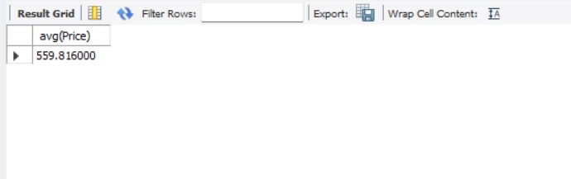

**-- to roundoff the avg amount:-**

**select ceil(559.81);**

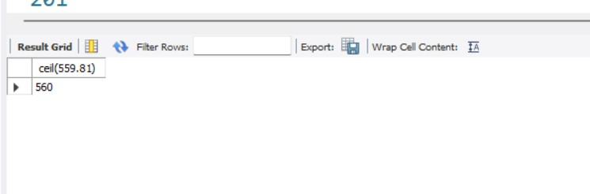

**-- Group by**

**select name,Price,count(*)as count from products**

**group by name;**

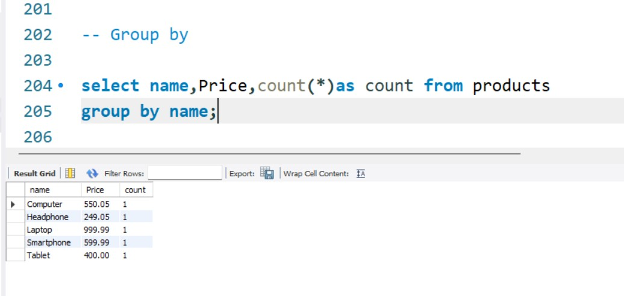

**select name,Price,count(*)as count from products**

**group by name having name="Laptop";**

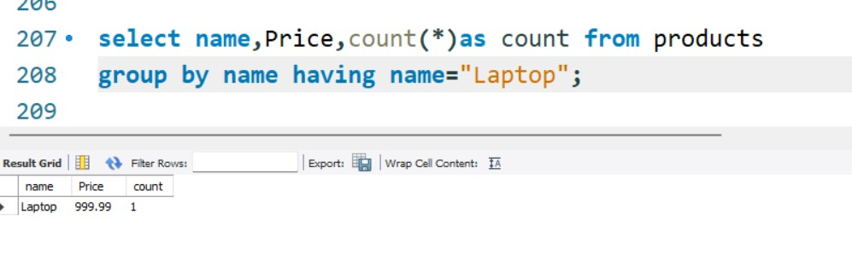

**select Price,name from products**

**where Price<899.99 group by name limit 3;**

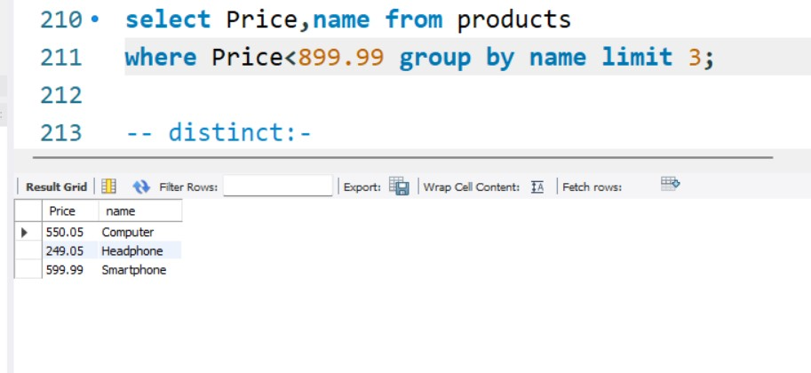

**-- distinct:-**

**select distinct address from Customers;**

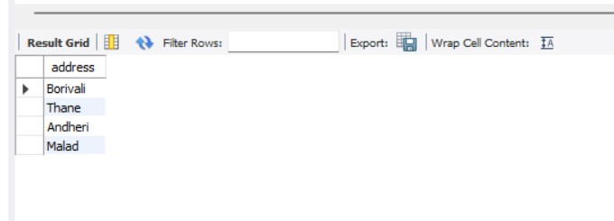

**-- Joins:-**

**select*from employees;**

**select*from customers;**

**select*from orders;**

**Select e.name,e.department,o.status from orders o inner join employees e**

**on o.employee_id = e.employee_id;**

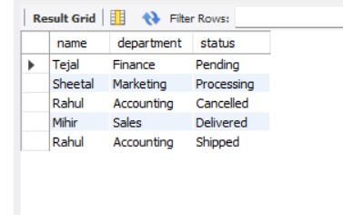

**select c.name,c.address,o.order_date from orders o right join customers c**

**on o.customer_id = c.customer_id;**

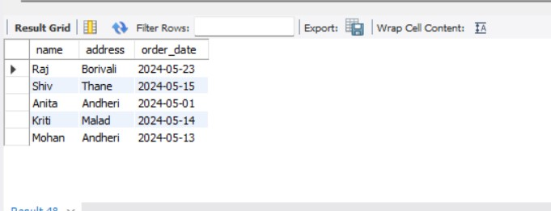

**select*from products;**

**select*from sales;**

**select*from products as p1 join products as P2**

**on p1.Product_id = p2.name_id;**

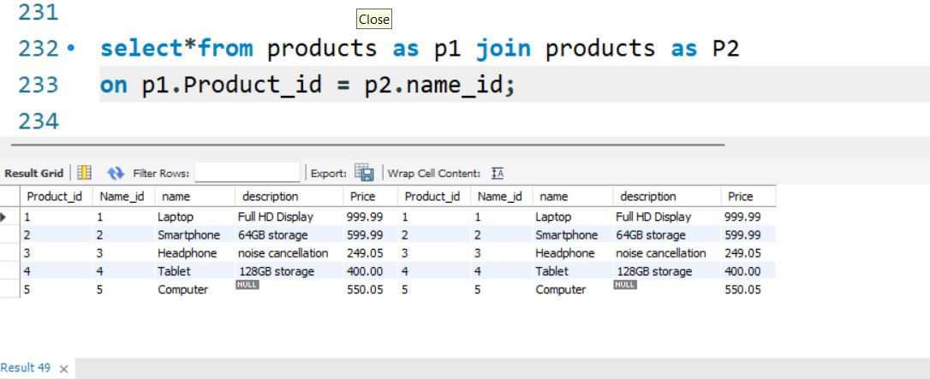

**select p.name,p.description,s.sale_date from sales s left join products P**

**on P.Product_id = s.sale_id;**

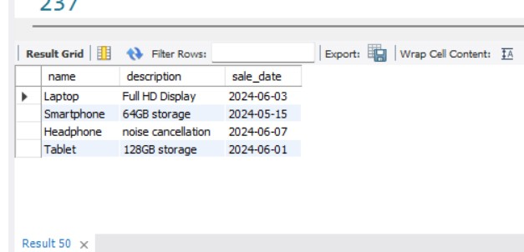

**-- Sub Query:-**

**select avg(price) from products;**



**select * from sales inner join products on Products.Product_id = Sales.sale_id**

**where products.price < (select avg(price) from products);**

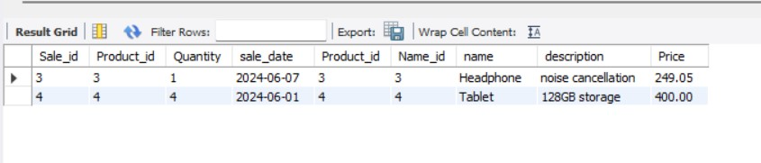

**select sum(price) from products;**

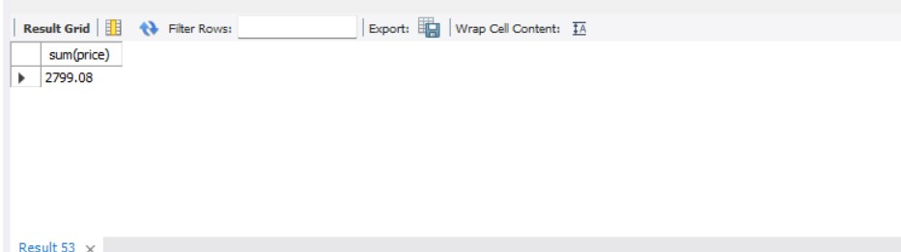

**select * from sales inner join products on Products.Product_id = Sales.sale_id**

**where products.price < (select sum(price) from products);**

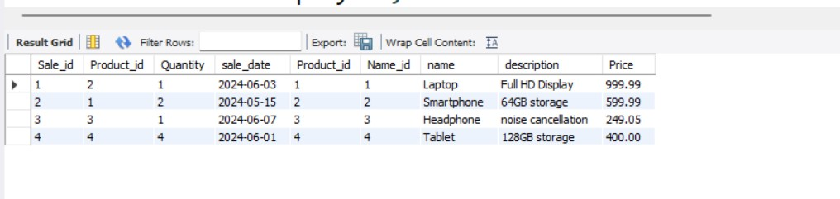

**alter table Employees**

**drop column hire_date;**

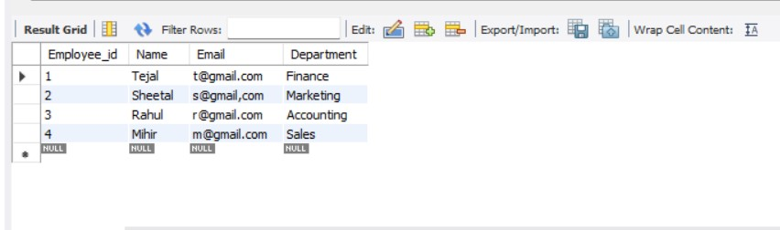

**alter table Employees**

**add hire_date bigint;**

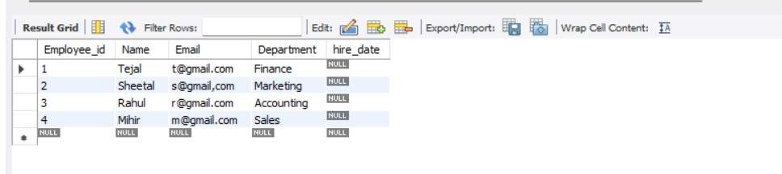

**alter table employees**

**modify column name varchar(30);**

**desc employees;**

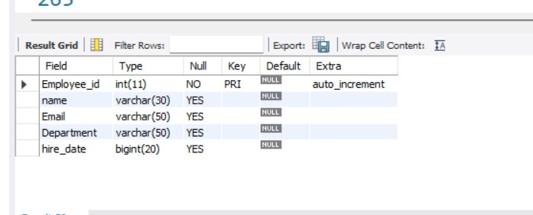

**alter table employees**

**change column hire_date joining_date date;**

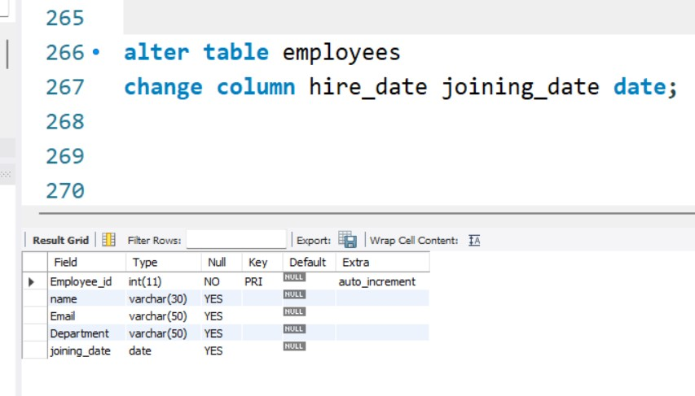

**update Employees**

**set joining_date = "2022-02-02"**

**where name ="Mihir";**

**table made for truncate query:-**

**Create table Festiv_offers**

**(id int auto_increment primary key,**

**isdiscount boolean);**

**insert into festiv_offers**

**(isdiscount)**

**values**

**(0),**

**(1),**

**(1),**

**(0);**

**select*from festiv_offers;**

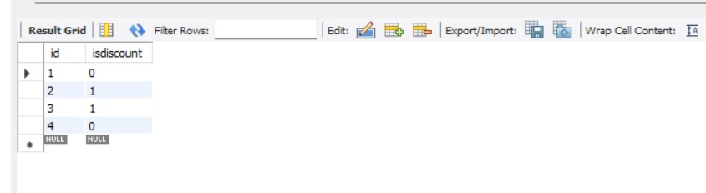

**truncate table festiv_offers;**

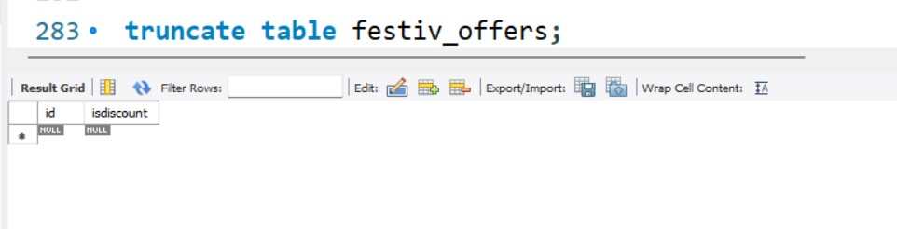

**select current_date();**

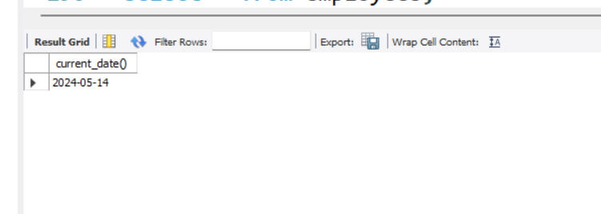

**select * from employees;**

**select day("2023-03-05");**

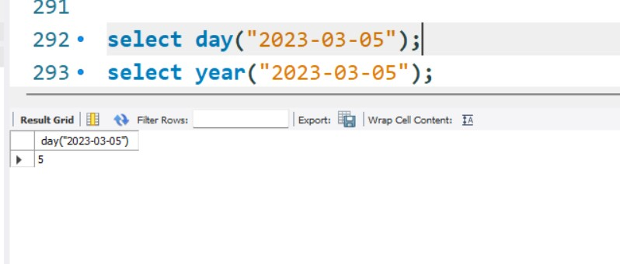

**select year("2023-03-05");**

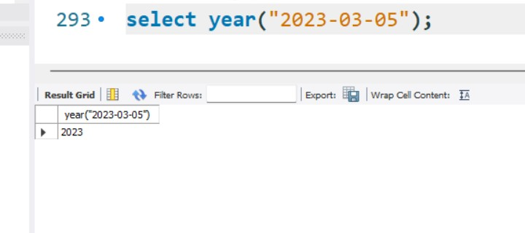

**select current_timestamp();**

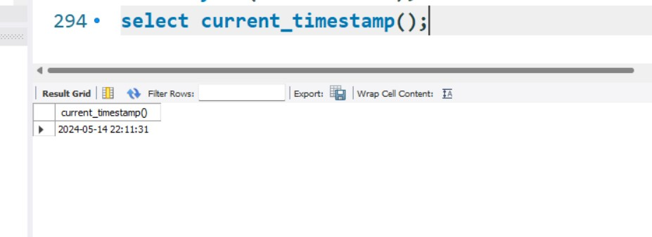

**---------------------------------------------xxxx---------------------------------------------**